**Course Methods Year 11 Test 2**

Student name: ________________ Teacher name: ________________

**Date: Wednesday 4th May 2022**

**Task type: Response**

**Time allowed for this task: 40 mins**

**Number of questions: 8**

**Materials required:** Formula Sheet and 1 page both sides of notes permitted.

No Calculators allowed.

Standard items: Pens (blue/black preferred), pencils (including coloured), sharpener, correction fluid/tape, eraser, ruler, highlighters

Special items: Drawing instruments.

**Marks available: 35 marks**

**Task weighting: 10 %**

**Formula sheet provided: Yes**

**Note: All part questions worth more than 2 marks require working to obtain full marks.**

1. **(1.1.8)** **(4 marks)**

A parabola that has its vertex at the point with coordinates (–1, 6) passes through the point (2, 10).

Find the equation of the parabola.

**Question 2 (1.1.10) (4 marks)**

Find the ***exact y-coordinate*** of the points of intersection of the curve with equation

$y=x^{2}$ and the circle $x^{2}+y^{2}=1$

**Question 3 (1.1.11) (3, 2, = 5 marks)**

Consider the quadratic equation $(-2p+1)x^{2}$ + $(p-2)x$ + $6p$ = 0.

1. Find the discriminant.
2. Re write the discriminant in perfect square form.

Question 4 (1.1.24) (2, 2 = 4 marks)

Given function $f$ with rule $f\left(x\right)=\sqrt{3x-11}$

1. State the domain of $f(x)$
2. Find $f(2a+3)$

**Question 5 (1.1.14) (4 marks)**

Given that the graph below is in the form $y=\frac{a}{x-b}+c$

Determine the values of $a, b, and c$

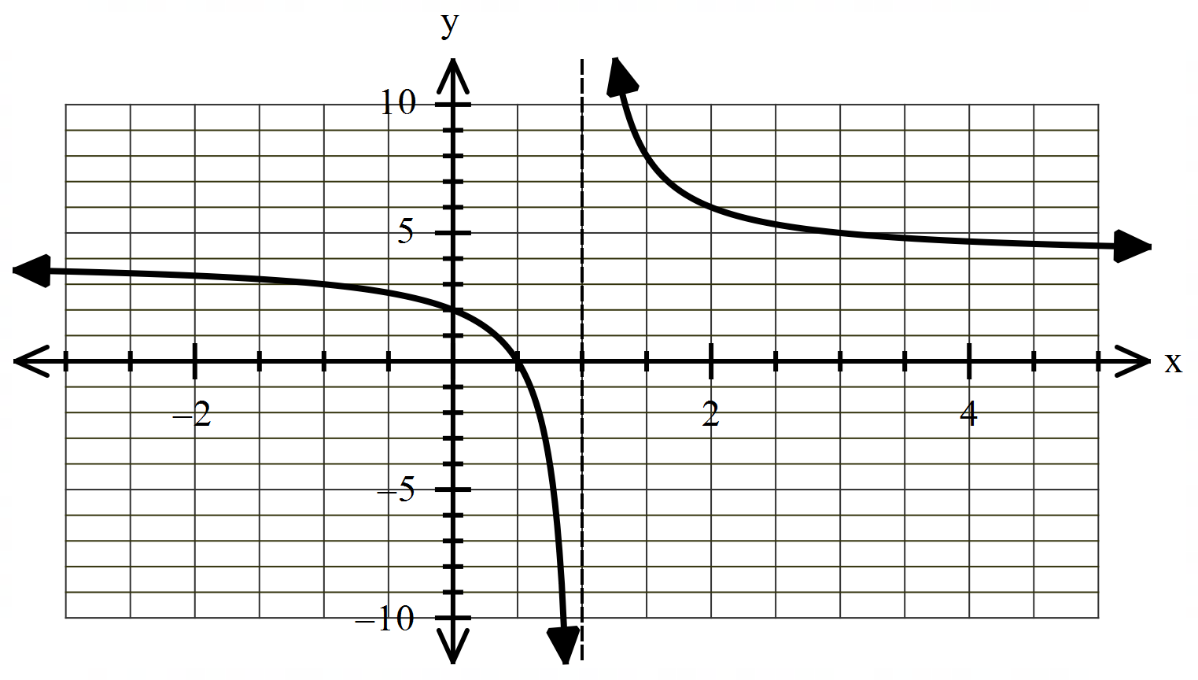

**Question 6 (1.1.15) (3 marks)**

Sketch $y=\sqrt{-x+1}+2$ within the domain

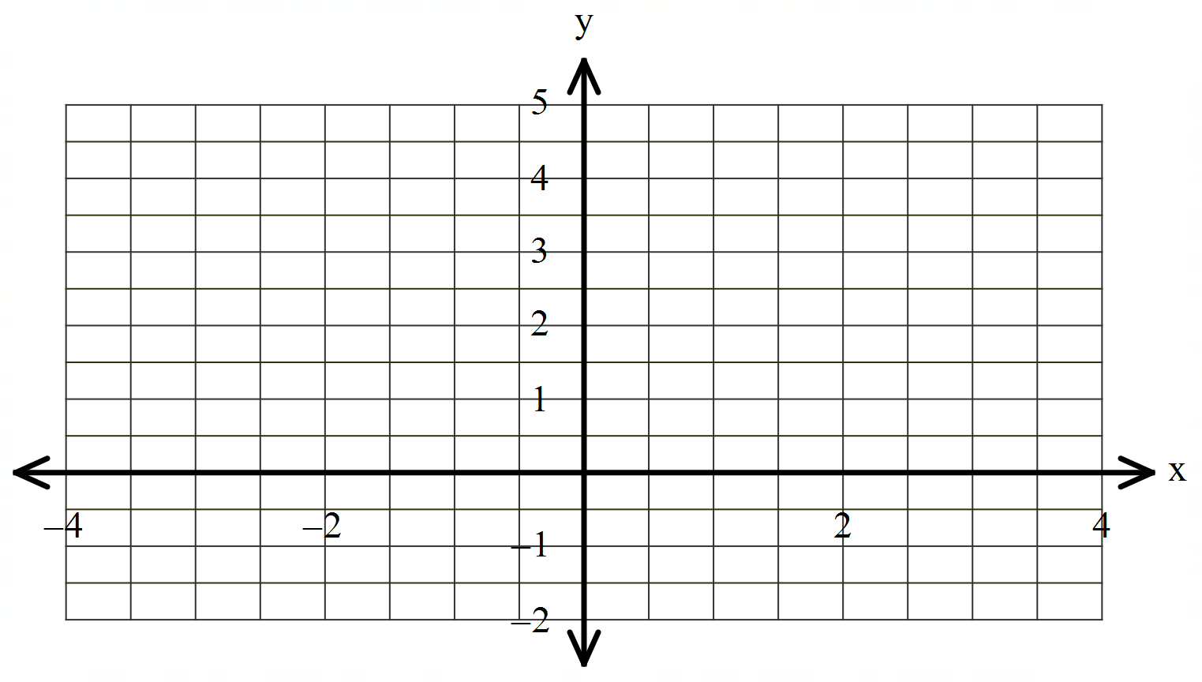



Question 7 (1.1.21, 1.1.22) (2, 4 = 6 marks)

Consider the Polynomial $G\left(m\right)=m^{3}-3m^{2}-6m+8$

1. Find $G(4)$
2. Hence or otherwise fully factorise $G(m)$

**Question 8 (1.1.26, 1.1.27) (1, 2, 2 = 5 marks)**

The function $y=f(x)$ is shown below.

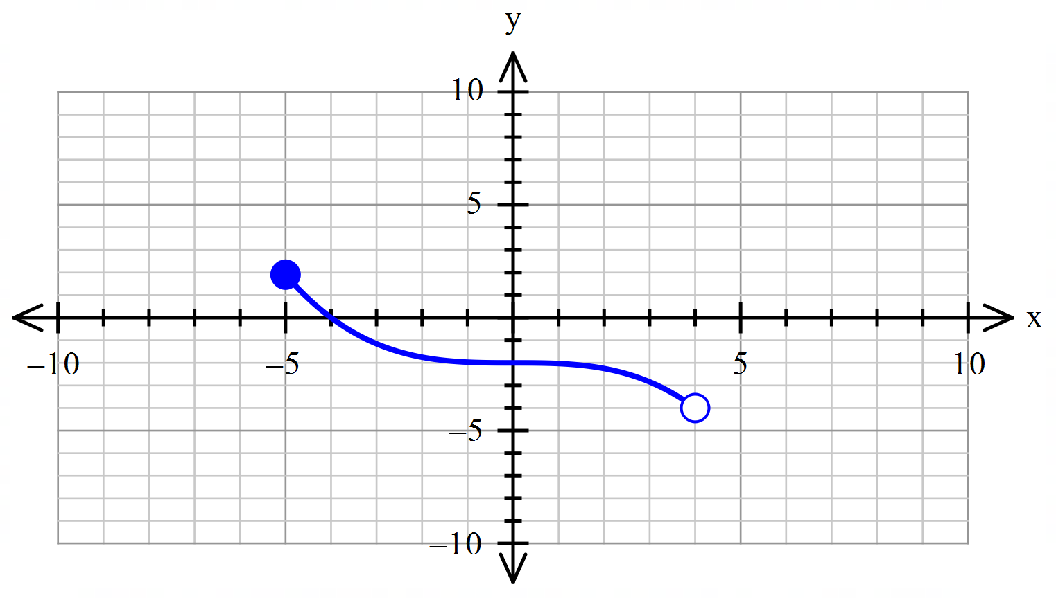

(a) State the range of $f(x)$. (1 mark)

(b) Another function is given by $g\left(x\right)=2f\left(x-3\right)$.

Describe the transformation required to produce $g(x)$ from $f(x)$. (2 marks)

(c) On the same axes above, sketch the graph of $y=f\left(2x\right)+2$. (2 marks)